Project overview
Thousands of people in remote villages in Mozambique have yet to be found and diagnosed with leprosy. Leprosy can be cured. But without fast treatment, the disease can cause permanent disability, destroying livelihoods and trapping people in poverty. You can help end leprosy in Mozambique by building a Community Hub, a central meeting place in remote villages where everyone is included.
A Community Hub will bring together volunteers, community health workers, faith leaders and people affected by leprosy to overcome this disease It is a place where health workers can be trained in diagnosis and treatment, and where people will learn that leprosy doesn’t need to be feared.
By helping to build a Hub, you won’t just be curing leprosy. Every villager will prosper through the work of a hub. You’ll help farmers to learn how to protect their crops from extreme weather and sell surplus produce to provide an income. The seeds of small businesses can be sown and nurtured here too, giving opportunities to young people and raising living standards across communities in a sustainable way.
Regional background
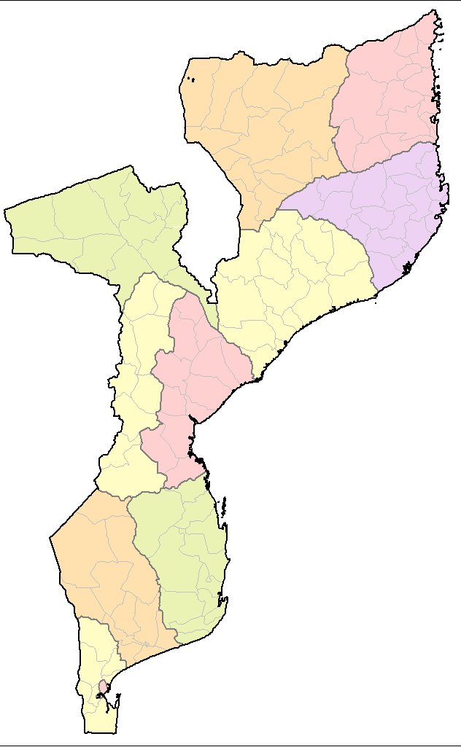
Mozambique is one of the poorest and most underdeveloped countries in the world (source: World Bank). It is also vulnerable to natural disasters. Last year, two cyclones caused catastrophic destruction and flooding. The country also suffers from severe droughts. These cause crop failures which result in famine and starvation. Agriculture, which is primarily subsistence farming, is the main livelihood. But Mozambique’s harsh climate makes it difficult to earn a living from the land and harvests often fail. This can create a vicious cycle as prices rise and families starve as they cannot afford to buy food.
The people of Mozambique suffer from widespread poverty and lack of basic healthcare. According to the United Nation’s 2019 Human Development Index, around two in three people live on less than £1.50 a day. Poor nutrition, lack of health education and poverty mean that disease is rife.
Cabo
Delgado
Community Hubs offer a real and practical solution
Community Hubs will become the beating heart for villages where leprosy lies undetected. Here, health workers and local leaders will detect and provide the cure for leprosy. In turn, those newly diagnosed will be trained to find others affected by leprosy. This will dramatically increase the numbers of cases identified.
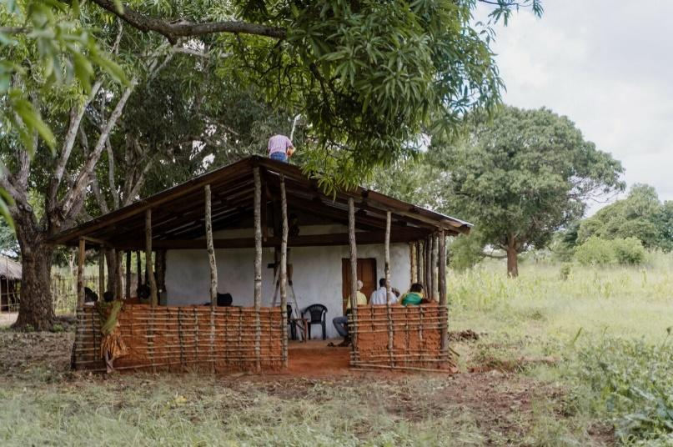
Community leaders will establish self-care groups so that people affected by leprosy can learn to manage their condition. These leaders will provide disability support and counselling to improve poor mental health caused by discrimination.
Hubs will be accessible to all. This includes females who are traditionally unable to access health or leprosy education because of cultural or gender barriers, as well as older people and disabled people.
In addition, we want to raise the understanding of all villagers to prevent fear and stigma. Hubs will be places where farmers can learn about protecting their crops from the extreme weather. Using solar-powered simple computers, they will be taught sustainable farming techniques. They will learn about weather preparedness and climate change. They will be supported on ways to enhance their incomes. Such training will lead to improved crop yields. Surplus crops can then be sold to generate an income, enabling villagers to have a more secure future.
A trial hub in a village in Mozambique
These Hubs will be life-changing for people affected by leprosy. Each Hub will serve at least two villages in either the Cabo Delgado Province or the Mocuba district in Zambezia Province. We expect to help more than 11,000 villagers in extreme poverty.
What your Project Donations will achieve
1. The build and establishment of five Community Hubs
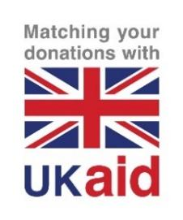
2. The building of a community building like a village hall
3. Setup of systems for participants database, Safeguarding and governance
4. Infrastructure in place ready to find new patients early, to provide education on leprosy and healthcare to tackle stigma & lack of understanding.
5. Ready to add the staff and Volunteers
Budget
ITEM | DESCRIPTION | COST (£)
Set-up costs | Construction of the Hub building | 1,500
 | To set up governance, safeguarding, management and feedback mechanisms; developing content in the local language and creating a participants’ database | 979
Equipment | Including a simple computer, solar panels and projector | 593
Activities | To set up theatre groups. Includes trainers’ fees, materials and equipment | 428
 | Sub-total per Hub | 3,500
 | Fundraising Target to build 4 Community Hubs | = 14,000
 | Plus 1 bonus Hub due to the Match Funding impact of funds received between 24th Jan to 24thApril making a total of …………….
 | Total of 5 Community Hubs built, setup and equipped

Additional items :- £100 buys a volunteer Changemaker a bicycle to reach nearby villages.

The Project for St Swithuns this time is to benefit from Match Funding for 3 months with a donation target during this period from January 24th to April 24th 2021 of £3,500 to be doubled to £7,000 and build two Hubs. The remainder of the year to raise a further £10,500 to build and equip a further three Hubs with a total amount of £14,000 raised and five Community Hubs built and equipped.

The overall project in Mozambique will start in October 2021 and end in December 2023 to build 40 Community Hubs in total.

Thank you so much for your contribution to these Hubs of hope and to find, cure and transform lives affected by leprosy.

